The layout and content needs improving
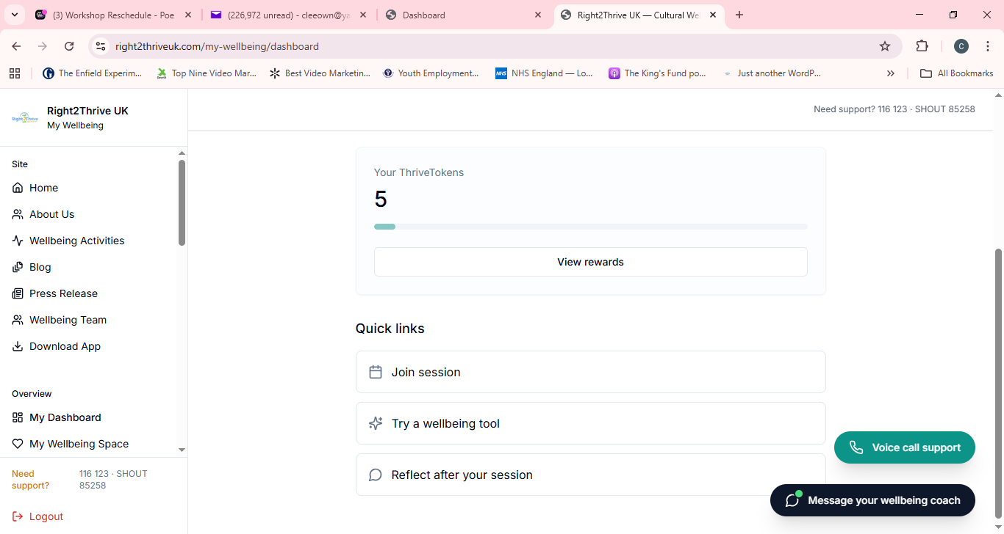

Have a look at this website rewards layout
https://apprenticenation.co.uk/rewards/
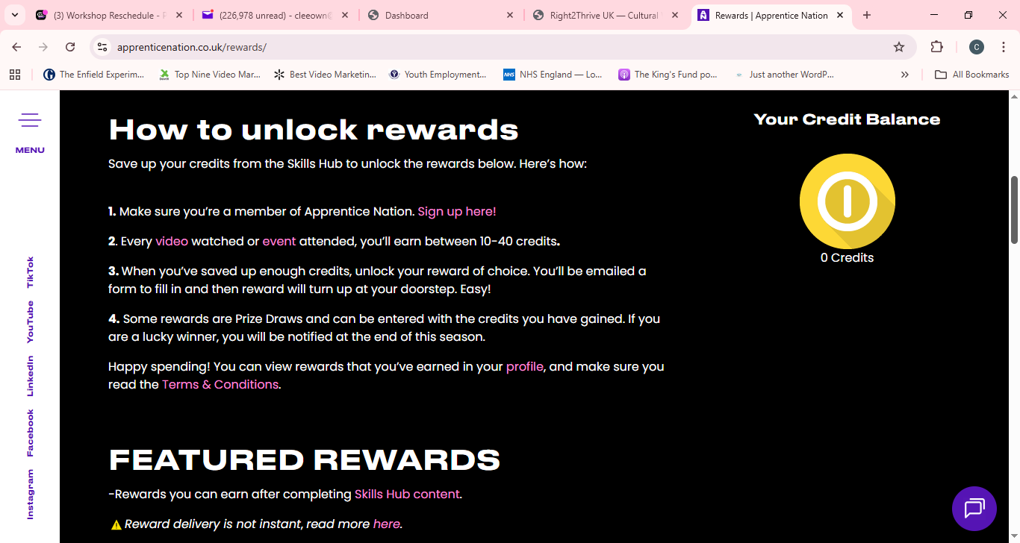

--------------------------------------------------------------------------------------------------------------

I AM UNABLE TO REGISTERED

